What is a binary tree ?

A binary tree is a tree data structure in which each parent node can have at most two children. Each node of a binary tree consists of three items:
- data item
- address of left child
- address of right child
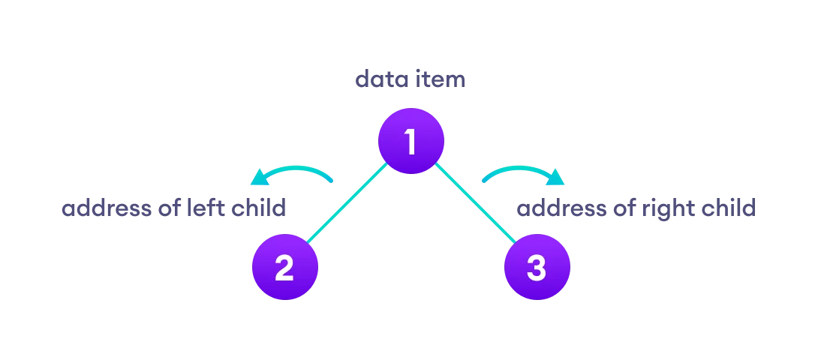
A binary tree T is defined as a finite set of elements, called nodes, such that:
(a) T is empty (called the null tree or empty tree), or
(b) T contains a distinguished node R, called the root of
T, and the remaining nodes of T form an ordered
pair of disjoint binary trees T1 and T2.

Binary tree representation
- B is a left successor and C is a right successor of the
node A.
- The left subtree of the root A consists of the nodes B,
D, E and F, and the right subtree of A consists of the
nodes C, G, H, J, K and L.

which are similar and which are dissimilar below figure?
The three trees (a), (c) and (d) are similar. In particular, the trees (a) and (c) are copies since they also have the same data at corresponding nodes. The tree (b) is neither similar nor a copy of the tree (d) because, in a binary tree, we distinguish between a left successor and a right successor even when there is only one successor.

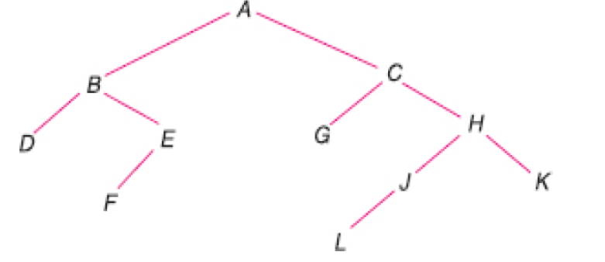
Linked representation of the above figure is depicted below:
The array representation of the above binary tree is below

Draw Sequential Representation of Binary Trees of given figure

Traversing a binary tree T with root R by three algorithms
Preorder
(1) Process the root R.
(2) Traverse the left subtree of R in preorder.
(3) Traverse the right subtree of R in preorder.
Inorder
(1) Traverse the left subtree of R in inorder.
(2) Process the root R.
(3) Traverse the right subtree of R in inorder.
Postorder
(1) Traverse the left subtree of R in postorder.
(2) Traverse the right subtree of R in postorder.
(3) Process the root

Write preorder postorder and Inorder traversal of the below binary tree.
(a) The preorder traversal [ ROOT LEFT RIGHT ] :
Hence ABDECF is the preorder traversal of T.
(b) The inorder traversal [ LEFT ROOT RIGHT ] :
Hence DBEACF is the inorder traversal of T.
(c) The postorder traversal [ LEFT RIGHT ROOT ] :
Hence DEBFCA is the postorder traversal of T.

Get the Preorder, Inorder, PostOrder traversal of the following figure of binary tree
- Preorder :
- Inorder
- Postorder

- PreOrder: [ ROOT LEFT RIGHT ]
Harris Cohen Brown Green Davis Evans Lewis Kelly Rubin
- InOrder: [ LEFT ROOT RIGHT ]
Brown Cohen Davis Evans Green Harris Kelly Lewis Rubin
- PostOrder: [ LEFT RIGHT ROOT ]
Brown Evans Davis Green Cohen Kelly Rubin Lewis Harris

Draw the Binary Tree from the given InOrder and PostOrder traversal
Draw the binary tree

